Computer Vision Homework 7

Name: 黃新予

Student ID: f08922136

1. **Environment Setup  
   Language: Python 3 (on VS code)  
   Library: numpy, PIL**
2. Q1: Write a program which does thinning on a downsampled image (lena.bmp).  
   step 1: binarize the lena.bmp  
   step 2: down-sampling the original binarized lean.bmp from 512*512 to 64*64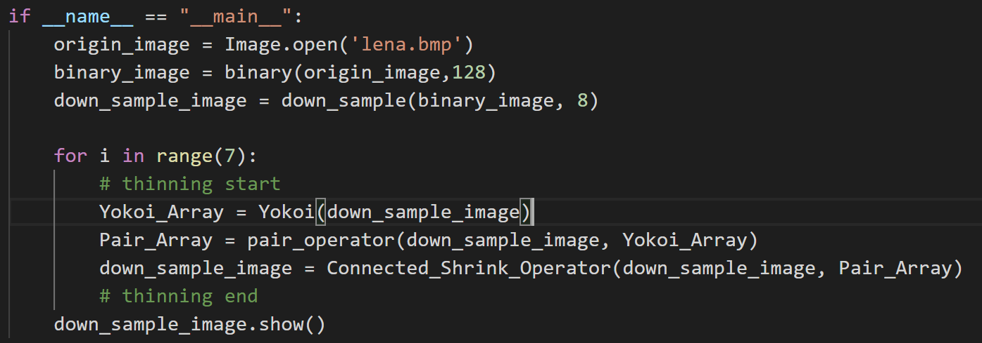  
     
   step 3: according to the announcement, implement the thinning operator.  
   step 3-1: create Yokoi connectivity number array (use the function from homework 6)  
     
   step 3-2: use Yokoi connectivity number created from step 3-1 to create Pair array  
   a). implement **Pair Relationship Operator h function**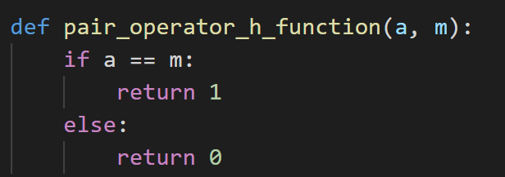  
   b) implement **Pair Relationship Operator output function** 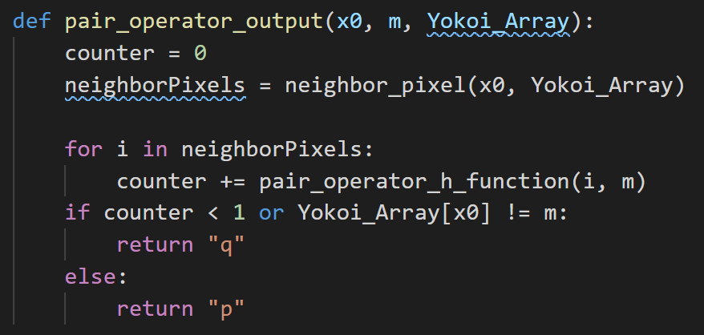  
   c) implement **Pair Relationship Operator**  
   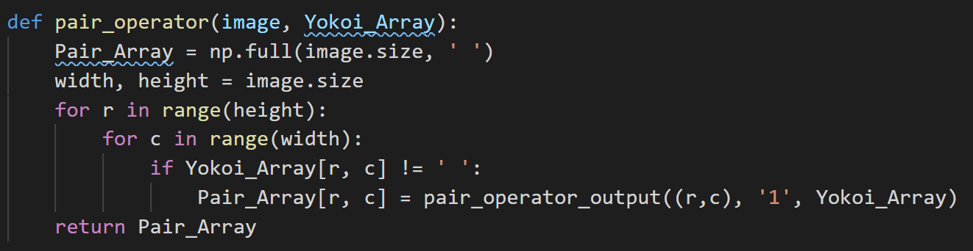  
     
   step 3-3: using Pair array created from step 3 to implement **Connected Shrink Operator**a) implement **Connected_Shrink_Operator h function**  
   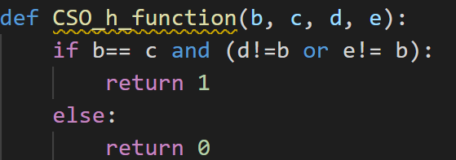  
   b) implement **Connected_Shrink_Operator f function**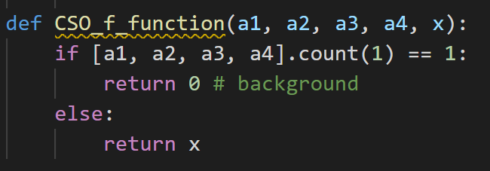c) using pair array and cso h function and cso function to update the original image  
   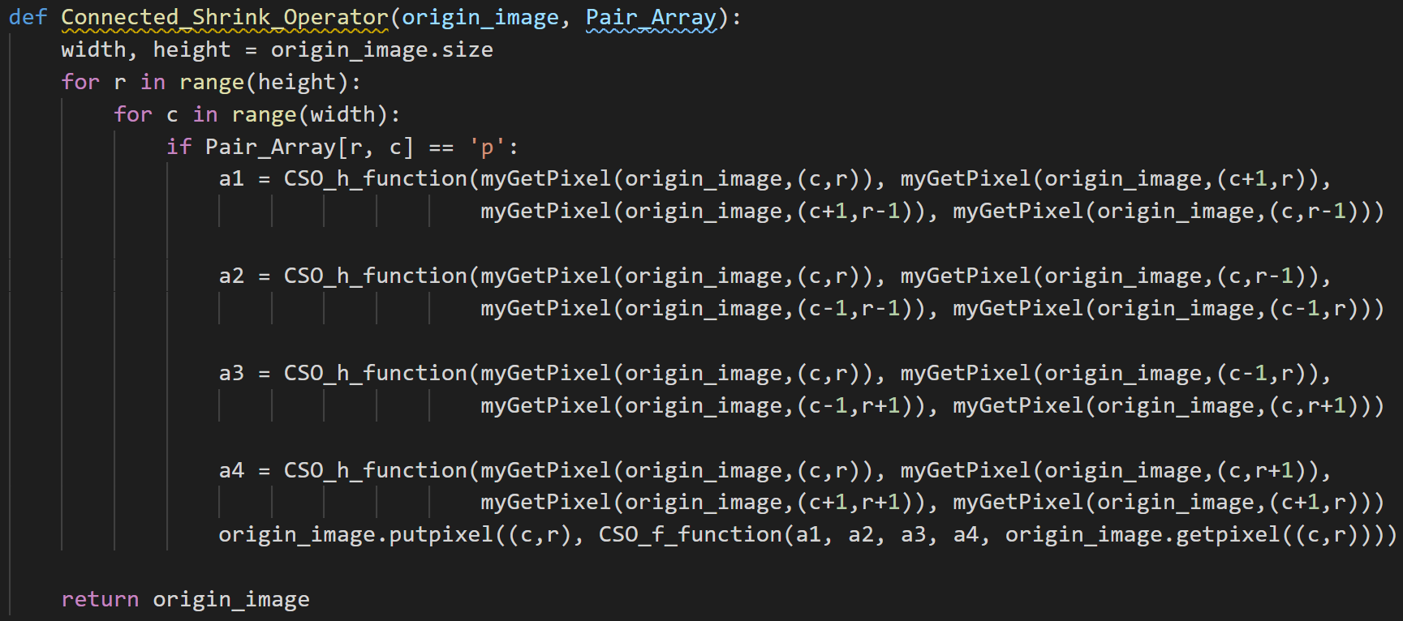  
     
   step 4: repeat step 3 for 7 time and get the result image  
   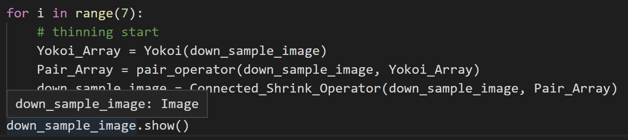  
     
   result image:   
   